Systematic Biblical Truth
God’s Word: Modern Translations

I. Overview:
A. There are approximately 50 English translations of the Bible. There are primarily two
reasons for different English Bible versions.
1. The English language changes continuously. Over time, the Bible needs to be
updated to still communicate with the readers.

II. Methodologies.
1. There are different methodologies for how to best render the original Bible
languages (Hebrew, Greek, Aramaic).
A. Formal Equivalence – Literal word for word with the original
languages. (NASB- New American Standard; ESV- English Standard
Version; RESV- New Revised Standard Version; NKJV- New King
James Version; KJV- King James Version).
B. Dynamic Equivalence – Seeks to reproduce the original text using
modern language and expression to communicate the message of the
Bible. DE is less concerned with exact word for word translation as it is
communicating the thought of the verse. (NIrV- New International
Readers Version; NLT- New Living Translation; GNT- Good News
Translation.)
C. “Hybrid” Translations, officially called Optimal Equivalence – A
combination of both Formal and Dynamic Equivalences. Uses word for
word translation when possible and a thought for thought approach.
(NIV- New International Version; NET- New English Translation;
CSB- Christian Standard and HCSB- Holman Christian Standard).
D. Examples:
John 3:16
Very Literal:
For God did so love the world, that His Son—the only begotten—He gave, that every one who is believing in him may not perish, but may have life age-during. (Youngs Literal Translation).
Formal Equivalence:
For God so loved the world that He gave His only begotten Son, that whoever believes in Him should not perish but have everlasting life (New King James Version).
Dynamic Equivalence:
The Lord is my Shepherd; I shall not want (New Living Translation).
Optimal Equivalence:
For this is the way God loved the world: He gave his one and only Son, so that everyone who believes in him will not perish but have eternal life (New English Translation).
---
Problems:
A difference in meaning can result from methodologies—Exodus 15:25
When Moses throws the tree into the bitter waters of Marah, the NASB says the waters became sweet. On the other hand, the NIV says the water became fit to drink. The Hebrew is literally “sweet”.
---
Translation Summaries:
- 1516 Textus Receptus—The first Greek translation of New Testament assembled by Erasmus. This became the base for the German Luther Bible, the Tyndale and the King James. Some modern texts referred to TR among other writings. Based mostly on the Byzantine writings, a less reliable source than the Alexandrian writings. [Formal]

- 1526 Tyndale Translation—the first English translation of the New Testament put together by William Tyndale. [Formal]
- 1611 King James Version. The version used today is the 1769 translation. [Formal]
- 1901 American Standard Version. A corrective translation for the KJV. [Formal]
- 1952 Revised Standard Version—A corrective translation for the American Standard Version. This Became the basis for the NASB, ESV. [Formal]
- 1975 New American Standard. The 1995 version is the newest translation to date. [Formal]
- 1975 New King James. [Formal]
- 1978 New International Version—The most popular translation today. The goal was to “read and understand” the Bible. Warning: The 2011 version is the latest and is gender-neutral. [Optimal]
- 1996 New Living Bible—A redo of the Living Bible which was a paraphrase not a translation. The goal is “to increase the level of precision without sacrificing the text easy to understand quality”. [Dynamic]

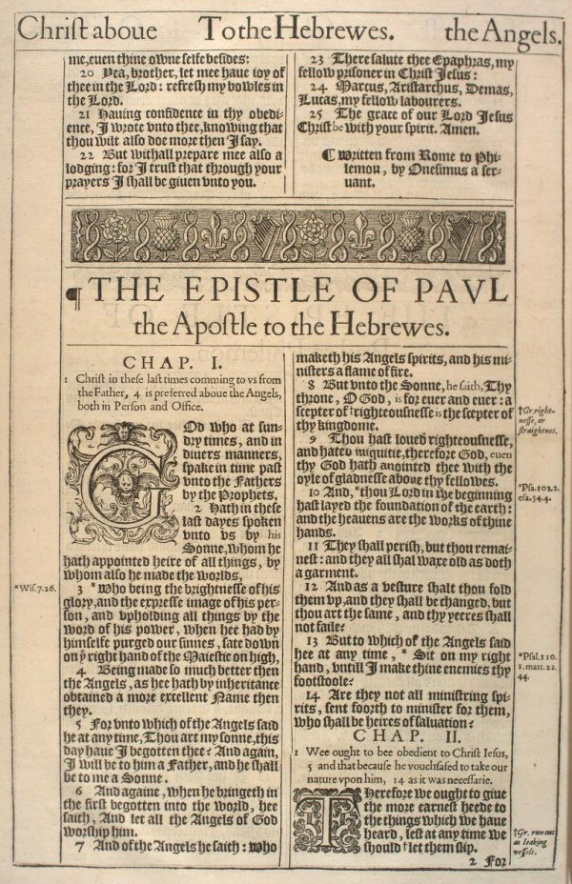
A word about the Apocrypha

Tobit—“Almsgiving saves from death and purges away every sin (Tob. 1`2:9).”
Ecclesiasticus—“Yoke and thong will bow the neck. For a wicked slave there are racks and tortures.”

What’s wrong with these verses?

- Written between 200AD and 200BC.
- Some claim to be written by Adam, Enoch, Moses and Ezra
- Purpose—to sustain the Jews during their suffering (especially through the Maccabean period, intertestament.
- Because of their fanciful nature, the Jews did not accept them as the word of God
- Apocrypha means “hidden”.
- Awarded full canon status by the Roman Catholic church at the Council of Trent in 1548.
- Reasons to reject:
1. No Jewish list of the O.T. books ever contained the Apocrypha.
2. Jesus quoted from the O.T. all the time, never did He quote from or even mention anything from the Apocrypha.
3. All the canonical collections for the first 400 years after Christ did not include any of the Apocrypha.
4. Much of the doctrines taught in the Apocrypha go directly against the teachings in the accepted canon.
5. It is through the Apocrypha that erroneous teachings such as purgatory, atonement by almsgiving, prayers for the dead, justification for cruelty to slaves, scorn for womanhood, etc.
6. None of the Apocrypha make any claims within themselves to be the Word of God.

